**39.ALV_GRID_CATALOGMERGE Output**

Below is the Selection screen .Give a suitable CARRID and Execute.

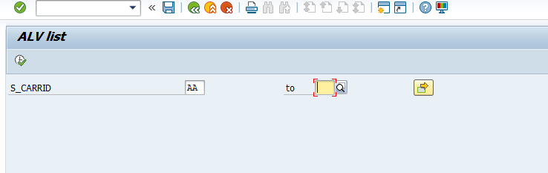

The expected output is as follows

